
Company
Logotype

Cone Beam Computed Tomography- Report



Porur Dental X-rays & CBCT

Patient Name : Mrs. Santhanalakshmi | Date of Report : 11.08.2024
Age/ Gender : 73 years/ Female | Region of Interest : CBCT Full Skull
Referring doctor: Dr. S. Selvaganesh | Indication : Implant assessment
Clinical Notes: Nil
PATIENT INFORMATION

CBCT- Full Skull provided
CBCT – IMAGE DETAILS

RADIOGRAPHIC INTERPRETATION

- Complete loss of crown and root structure in relation to 16, 17, 18, 21, 22, 25, 26, 27, 28, 31, 32, 37, 38, 41, 42, 46, 48.
- The alveolar ridge in relation to the maxillary and mandibular alveolar ridge is present with normal trabecular pattern.
- Presence of bone loss extending upto the middle third of all the teeth that are present is noted.

IMPLANT ASSESSMENT

 | 21 region | 22 region
Sub-Crestal | 2.7 | 2.1
Mid- Crestal | 3.9 | 3.1
Distance between the alveolar ridge and Floor of the Nasal cavity (in mm) | 14.4 | 8.9

 | 16 region | 17 region | 25 region | 26 region | 27 region
Sub-Crestal (in mm) | - | - | 5 | - | -
Mid- Crestal (in mm) | - | - | - | - | -
Distance between the alveolar ridge and floor of the maxillary sinus (in mm) | 0.9 | 0.7 | 3.5- | 0.6 | 0.7

 | 31 region | 32 region | 41 region | 42 region
Sub-Crestal (in mm) | 4.8 | 4.2 | 4.2 | 4.4
Mid- Crestal (in mm) | 7.3 | 5.7 | 7.1 | 5.2
Distance between alveolar ridge and the inferior border of mandible (in mm) | 21.8 | 21.5 | 22.1 | 23.6

 | 37 region | 46 region
Sub-Crestal (in mm) | 10.5 | 3.9
Mid- Crestal (in mm) | 13.2 | 4.5
Distance between alveolar ridge and the inferior alveolar nerve canal (in mm) | 6.6 | 10.4
Distance between alveolar ridge and the inferior border of mandible (in mm) | 18 | 23.7

RADIOGRAPHIC IMPRESSION

- Partially edentulous maxillary and mandibular arch.
- Generalized chronic periodontitis.

Kindly correlate with clinical findings


IMAGES FOR REFERENCE

RECONSTRUCTED PANORAMIC VIEW

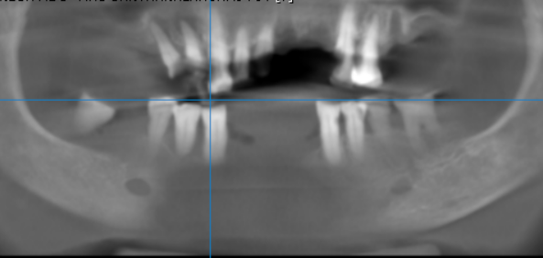

3-DIMENSIONAL VIEW

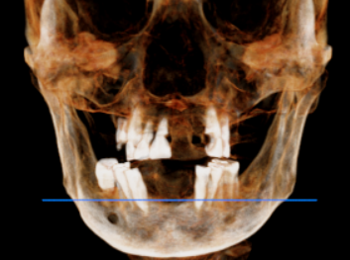

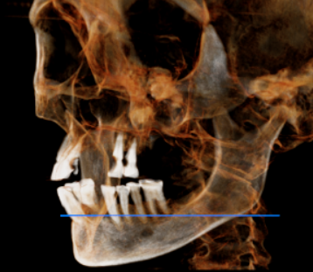
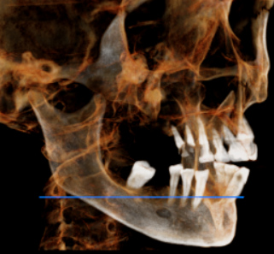

CROSS SECTIONAL VIEW

16 region | 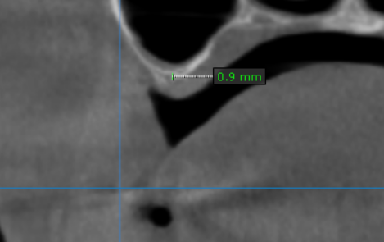
17 region | 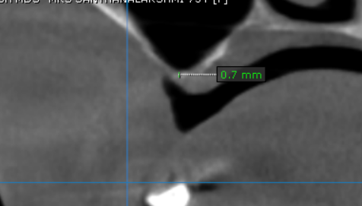
21 region | 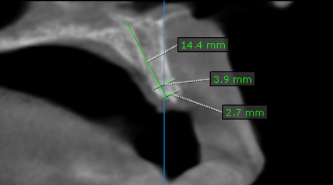
22 region | 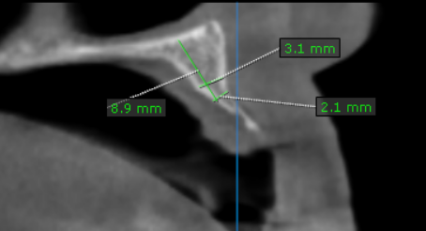
25 region | 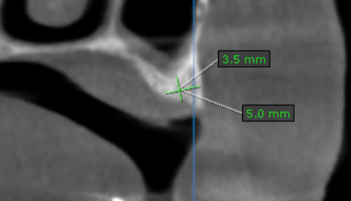
26 region | 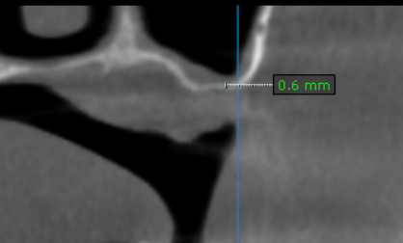
27 region | 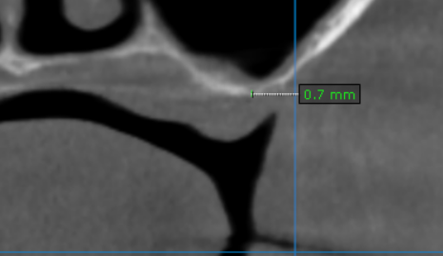
31 region | 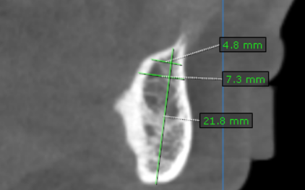
32 region | 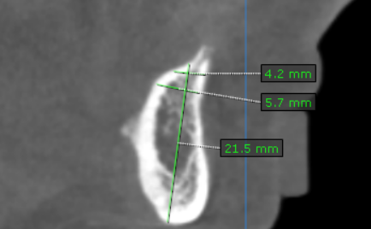
37 region | 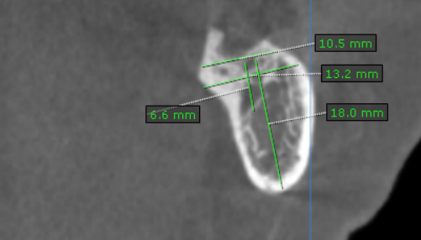
41 region | 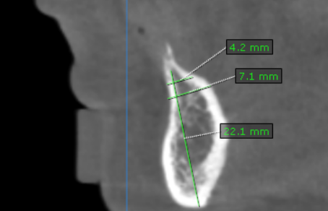
42 region | 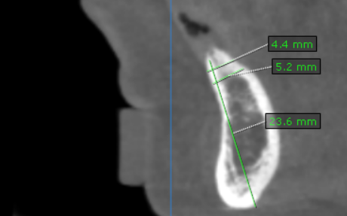
46 region | 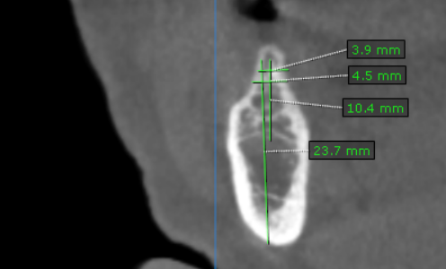

**** End of report ****

